1. Jim hates fracking. He wants to make it illegal to remove natural grass from the ground because it might contaminate the drinking water. Which of the following is the most effective strategy for making fracking illegal?
- Organize a march outside of the city government buildings
- Boycott Natural Gas
- Vote to make Fracking illegal
- Organize a Picket line outside of the Natural Gas Company
2. Jim: “Hey Congressman, I will give you $100,000 to spend on your next political campaign. In return, you have to make Fracking illegal in the US.”
Congressman: “Sure thing, dude.”
Based on the quotes above, select the answer that best explains the quote above.
- This is Lobbying and it’s legal
- This is Lobbying and it’s against the law
- This is Gerrymandering and is legal at the Federal level
- This is a Boycott and it’s legal for citizen’s
3. Jim just freaked out in the grocery store. Last week Jim bought a soda for $1. Today, it cost him $1.05. Jim lost his mind and was kicked out. The grocery store tried to explain the situation. What should the Grocery store tried to say?
A. Your money increases in value as the supply goes up – it’s inflation, you can’t by what you used to
B. Your money increases in value as the supply goes down – it’s inflation, you can’t by what you used to
C. Your money decreases in value as the supply goes down – it’s inflation, you can’t by what you used to
D. Your money decreases in value as the supply goes up – it’s inflation, you can’t by what you used to

4. This North Carolina document annulled (removed) the King’s Laws in 1775.
A. Mecklenburg Resolves
B. Halifax Resolves
C. Charlotte Courier
D. Raleigh Write-Up

5. This North Carolina document declared independence from Great Britain in 1776. It was written three months before the Declaration of Independence.
A. Mecklenburg Resolves
B. Halifax Resolves
C. Declaration of Independence
D. Raleigh Write-Up
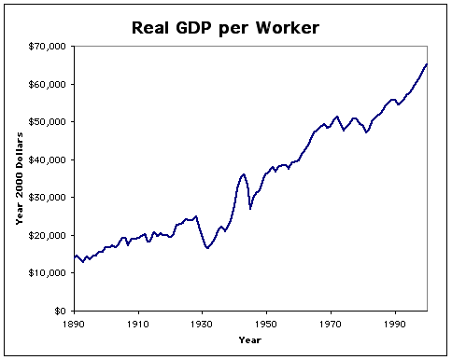
6. Analyze the Gross Domestic Product chart above. Which of the following CANNOT be surmised (concluded)?
- Overall, The economy Is growing
- Economies are cyclical. Sometimes they grow and sometimes the shrink
- Unemployment is higher in 1990 than in 1930
- Between 1930 and 1950, the economy shrunk at least twice
7. Which of the following is NOT true about the Articles of Confederation?
- The articles created a strong national government
- The articles failed to establish a common currency in the US
- This was the first national government in the US
- The articles were too weak and rebellions threatened to destroy the nation
8. Which of the following defines the civics and government concept of Popular Sovereignty?
- The government cannot do anything it wants.
- The government is divided into three separate branches.
- People have the power. This power is exercised by voting.
- The name of system that explains how the branches of government limit each other.
9. Which of the following defines the civics and government concept of Limited Government?
- The government cannot do anything it wants.
- The government is divided into three separate branches.
- People have the power. This power is exercised by voting.
- The name of system that explains how the branches of government limit each other.
10. Which of the following defines the civics and government concept of Checks and Balances?
- The government cannot do anything it wants.
- The government is divided into three separate branches.
- People have the power. This power is exercised by voting.
- The name of system that explains how the branches of government limit each other.
11. Which of the following defines the civics and government concept of Separation of Powers?
- The government cannot do anything it wants.
- The government is divided into three separate branches.
- People have the power. This power is exercised by voting.
- The name of system that explains how the branches of government limit each other.
12. Which of the following defines the civics and government concept of Republicanism?
- People are born with these and it is the government’s job to protect them
- The division of power between National, State, and Local Government.
- The Study of citizenship.
- Citizens elect officials to make laws on our behalf.
13. Which of the following defines the civics and government concept of Individual Rights?
- People are born with these and it is the government’s job to protect them
- The division of power between National, State, and Local Government.
- The Study of citizenship.
- Citizens elect officials to make laws on our behalf.
14. Which of the following defines the civics and government concept of Federalism?
- People are born with these and it is the government’s job to protect them
- The division of power between National, State, and Local Government.
- The Study of citizenship.
- Citizens elect officials to make laws on our behalf.

15. Which of the following defines civics?
- People are born with these and it is the government’s job to protect them
- The division of power between National, State, and Local Government.
- The Study of citizenship.
- Citizens elect officials to make laws on our behalf.
16. Which of the following did NOT cause The Great Migration?
A. Jim Crow Laws
B. Lack of economic opportunities
C. A surplus of jobs
D. An alarming rate of lynching

17. Which of the following does NOT describe the Virginia Colony?
A. It was a business venture
B. The Virginia colony established the first representative government in America
C. The original plan was to make money from planting cash crops
D. Gold was not discovered, but the Virginia Company profited from raising Tobacco

18. In terms of Mercantilism, what is vital to a European nation’s success?
A. Importing goods at any price
B. Exporting goods to America
C. Acquiring more lands than other nations allows for cheap importing (mainly in America)
D. Slavery did not make a difference during mercantile trade

19. How did the Proclamation of 1763 affect the British Colonies?
A. It limited western movement of settlers
B. It led to an increase in fur trading
C. It prevented trade with American Indians
D. It led to the French and Indian War

20. Which of the following is NOT a part of the Declaration of Independence?
A. Unalienable Rights
B. Religious Freedom
C. Grievances
D. Declared Independence from England

21. Which of the following citizens made smallest impact on North Carolina History?
- Jesse Helms
- Henry Berry Lowry
- Terry Sanford
- Ella Baker
22. Analyze the picture below.
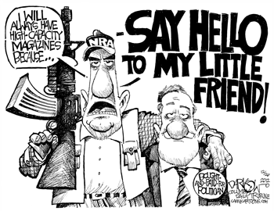
What statement is the cartoonist making with this political cartoon?
- Our democracy is weak because citizens under 18 cannot vote.
- The 2nd Amendment protects citizens’ right to own guns
- Picketing is the most effective form of civic participation
- Lobbying undermines the legitimacy of our democracy
23. Analyze the picture below.
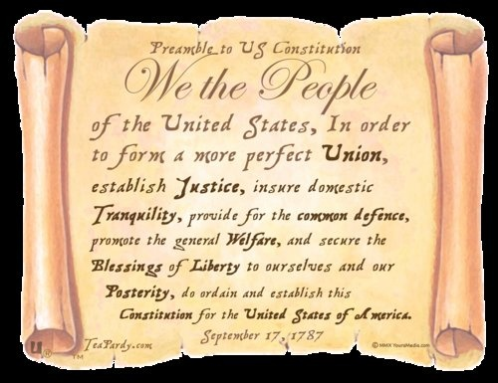
What Government concept is represented by the phrase “we the people” at the beginning of the US Constitution?
- Popular Sovereignty
- Limited Government
- Separation of Powers
- Rule of Law

24. Which of the following items is NOT scarce?
A. Potatoes
B. Oil
C. Gold
D. Americans with college degrees in Math & Science

25. On February 1, 1960, four college students sat down at a “whites-only” Woolworth’s lunch counter in Greensboro, North Carolina. They asked to be served and were refused. These students used the “sit-in” as nonviolent action against racial segregation. Images of the sit-ins spread through television and newspapers nationwide.
Which statement reflects the influence on the civil rights movement of citizen action in Greensboro, North Carolina?
A. Sit-ins failed to gain support, and lunch counters remained segregated.
B. Sit-ins spread to other cities, helping to desegregate public facilities.
C. Sit-ins, which were not supported by national civil rights leaders, slowed progress for desegregation.
D. Sit-ins gained national support, but little action was taken by state governments to improve civil rights.

